# Module 1. Introduction

## Topics

* IaaS vs. PaaS
* Azure Regions
* Availability Zones
* Basic Azure Services (Virtual Machines, Web Apps, Storage, Azure SQL Database, Virtual Networks)
* Azure Subscriptions
* Azure Resource Groups
* ARM Templates
* Virtual Machines (Size & Pricing, Availability Sets, High Availability)
* Scaling (Scale-up, Scale-out)
* Azure Portal
* Azure CLI
* Azure PowerShell (DSC)
* Virtual Networks Basics

## Recommended Courses

|  |  |  |  |  |  |
| --- | --- | --- | --- | --- | --- |
| Course Host | Course | $ | Module | MoSCoW | T, h |
| Pluralsight | [Developing with .NET on Microsoft Azure - Getting Started](https://app.pluralsight.com/library/courses/developing-dotnet-microsoft-azure-getting-started/table-of-contents) |  | Foundational Concepts | M | 0.75h |
| [Design a Compute Strategy for Microsoft Azure](https://app.pluralsight.com/library/courses/microsoft-azure-compute-strategy-design) | $ | *~~Azure Core Concepts~~* | S | 1h |
| *~~Using Azure Resource Manager~~* | M | 1h |
| Azure IaaS Compute Fundamentals | S | 1h |
| [Microsoft Azure Architecture - Getting Started](https://app.pluralsight.com/library/courses/azure-architecture-getting-started/) |  | *~~Cloud Computing Fundamentals~~* | C | 0.75h |
| *~~Cloud Computing Infrastructure Elements~~* | C | 0.75h |
| *~~The Hybrid Cloud~~* | C | 0.5h |
| *~~Platform as a Service~~* | S | 0.5h |
| Infrastructure as a Service | S | 0.5h |
| Microsoft Azure Deployment Planning | M | 0.75h |
| Lynda | [Planning a Microsoft Cloud Solution](https://www.lynda.com/Azure-tutorials/Planning-Microsoft-Cloud-Solution-2018-REVISION/724797-2.html) |  | 4. Azure Virtual Machines | M | 1h |
| Edx | [Microsoft: AZURE210x](https://courses.edx.org/courses/course-v1:Microsoft+AZURE210x+2T2018)  [Automating Azure Workloads](https://courses.edx.org/courses/course-v1:Microsoft+AZURE210x+2T2018) |  | Module 1. ARM Templates | C |  |
| Module 2. Runbooks | C |  |
| Module 3. Automation DSC | S |  |
| [Microsoft: AZURE202x](https://courses.edx.org/courses/course-v1:Microsoft+AZURE202x+2T2018/course/)  [Microsoft Azure Virtual Machines](https://courses.edx.org/courses/course-v1:Microsoft+AZURE202x+2T2018/course/) |  | Creating Virtual Machines | C |  |
| Configuring Virtual Machines | S |  |
| Virtual Machines Disks | C |  |
| Managing Virtual Machines | C |  |

## Recommended Reading

* [How to get started with Azure and .NET](https://blogs.msdn.microsoft.com/webdev/2018/09/04/how-to-get-started-with-azure-and-net/)
* ["The Developer's Guide to Azure"](https://azure.microsoft.com/ru-ru/campaigns/developer-guide/) free e-book
* [Migrate your .NET app to Azure](https://www.microsoft.com/net/apps/cloud/migrate-to-azure)
  + "Azure Quick Start Guide for .NET Developers"
  + "Modernize existing .NET apps with Azure Cloud and Windows Containers"
  + "DevOps with ASP.NET Core and Azure"

## Module Tasks

### Task 1. Additional Resources

1. Go to ["Microsoft Azure"](https://www.youtube.com/user/windowsazure) youtube channel and find "Azure Tips and Tricks" playlist.
2. Go to ["Azure Interactives"](http://azureinteractives.azurewebsites.net/) and open "Pricing" link on "Virtual Machines" card.
3. Download ["The Developer's Guide to Azure"](https://azure.microsoft.com/ru-ru/campaigns/developer-guide/) free book and read 1st and 2nd chapters.

### Task 2. “Migrate infrastructure to the Cloud” case

Your customer wants to move his production system to the Cloud. Figure 1 shows important business applications and user roles.

* HR Specialist and HR Manager uses “HR Console” desktop application that works with “HR Console Back-end” WCF application.
* HR Manager and Department Head also uses “HR Console” ASP.NET MVC application that provides some key features “HR Console” doesn’t implement.
* Department Head, Production Manager, and Production Employee use “Production Monitor” ASP.NET MVC application.
* Sales Manager and Sales People use “Sales” ASP.NET MVC application.
* There is only one database instance that all applications use.

The schema doesn’t include non-production environments and development infrastructure.

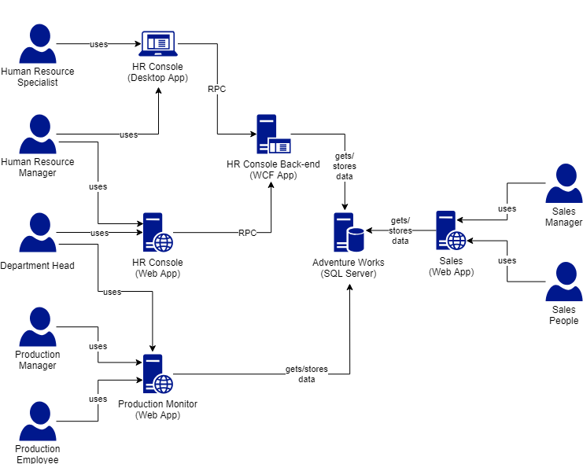

Figure 1. Enterprise production schema with applications and roles.

You are responsible for designing the new сloud infrastructure for this customer. Create the infrastructure design with all necessary VMs, Azure services, networks.

* Customer expects that the existed infrastructure will be migrated as is.
* Minimum changes to all existed applications. They are supported by sub-contractors, but they are not in active development.
* Customer is open to all your proposals, but they should sound reasonable.
* Start with one virtual network and subnet. Add more subnets and virtual networks if necessary.
* Don’t try to create “ideal” infrastructure from scratch.
* Consider different options, discuss the benefits/weaknesses with your mentor.
* Publish your schema to Teams when hard deadline will be reached.

### Task 3. Create infrastructure

Your customer already has an infrastructure design. See figure 2 for more details.

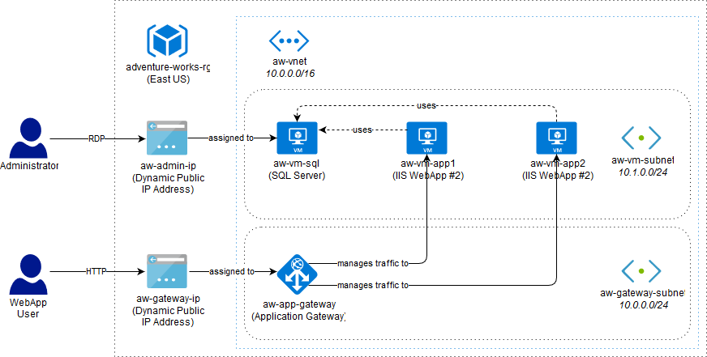

Figure 2. Infrastructure schema.

You are responsible for design implementation.

1. Use portal to create the infrastructure as it is shown on figure 2.
2. [Install AdventureWorks OLTP](https://docs.microsoft.com/en-us/sql/samples/adventureworks-install-configure) to aw-vm-sql VM.
3. Deploy [“adventure-forks”](https://github.com/epam-lab/adventure-forks/tree/initial) ASP.NET MVC application to aw-vm-app1 and aw-vm-app2 VM.
4. Set correct “Entities” connection string to make this app work on both instances. Don’t pay attention to other connection strings.
5. Run browser on aw-gateway-ip to make sure that both VM instances available.
6. Export ARM template for “adventure-works-rg” resource group.
7. Create an Azure CLI script for deploying the infrastructure.

### Task 4. (Optional) Create advanced infrastructure

1. Modify the figure 2 infrastructure to have highly available VMs using availability set.
2. Modify the application gateway settings to set path-bases routing rules:
   1. Traffic for “/Department/*” should go to aw-vm-app2 VM instance.
   2. Other traffic should go to aw-vm-app1 VM instance.
3. Create PowerShell script for infrastructure deployment.